- March 2024  - Budget Special  - Contact us  White House Mortgages Ltd  The White House  39 Saffron Road  Chafford Hundred  Essex RM16 6NA  01375 430 431  07973 313957  tonysilver@whmltdifa.co.uk  www.whmltdifa.co.uk | White House Newsletter  How did the Budget affect the Mortgage Market?  From a Mortgage Broker’s point of view, the Budget was something of a non-event. The only direct mention, was the change to holiday lets in favour of longer term Buy to Lets. Thankfully the expected 99% mortgages didn’t happen. With house prices rising by 1.2% in February, according to the Nationwide Price Index, and with this being the first positive monthly rise in ages, such a high loan to value in my view, would put First Time Buyers taking such a mortgage, far too exposed to possible negative equity, which no doubt would be blamed on the Brokers, for recommending a 99% LTV to an inexperienced buyer.  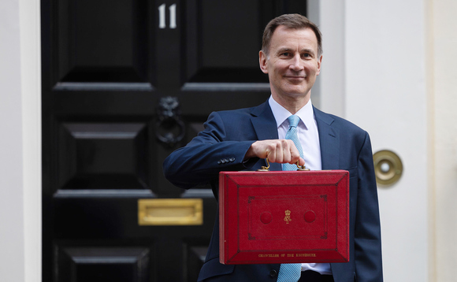  Something that wasn’t in Jeremy Hunt’s speech, but was buried somewhere within the 94 page Budget Document, was the Government’s plans to fully exit from it’s NatWest shareholding by 2025-26. To date the Government has raised £14.5bn from sales of the NatWest shareholding to date, with the sale expected to happen sometime in the Summer.
At the same time and outside of the Budget, over at the Nationwide, it was announced that it had agreed terms to acquire Virgin Money in a deal valued at £2.9bn. The deal
will see both the Nationwide and Virgin Money to continue to operate under their existing brands for approximately 6 years.

Also hidden in the text of the Budget Document, the Government will allow local authorities more flexibility in their use of right-to-buy receipts. The document stated that the Government will increase the cap from 40% to 50% of the percentage of the cost of a replacement home that can be funded from right-to-buy receipts. It will be interesting to see if this leads to a big push from cash strapped local authorities, to sell off their housing stock to right-to-buy tenants, in a boost to affordable housing.

The other Housing related headlines from the Budget were:
- Higher rate of tax paid on profits from selling property cut from 28% to 24% (there’s no tax on selling your residential home).
- Tax breaks for owners of holiday let properties scrapped.
- Stamp Duty tax break when purchasing multiple properties to end in June.

YOUR HOME IS AT RISK IF YOU DO NOT KEEP UP REPAYMENTS ON A MORTGAGE OR OTHER LOAN SECURED ON IT.
Written quotations on request. Published Fees Ts&Cs will apply. White House Mortgages Limited is Authorised and Regulated by the Financial Conduct Authority FCA:302190.

